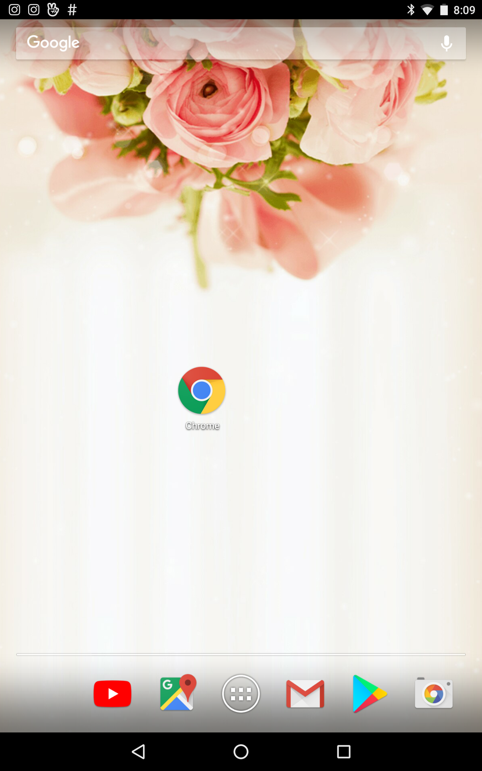 | 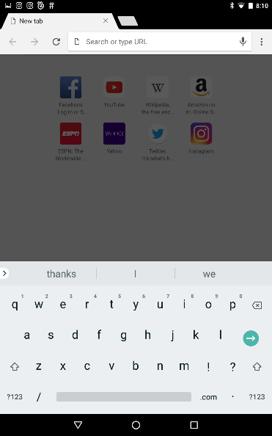 |  | 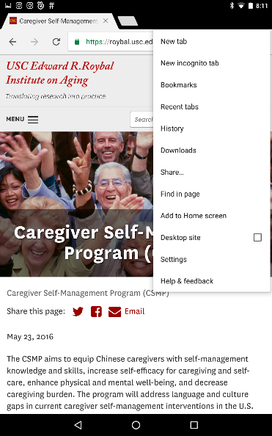 | 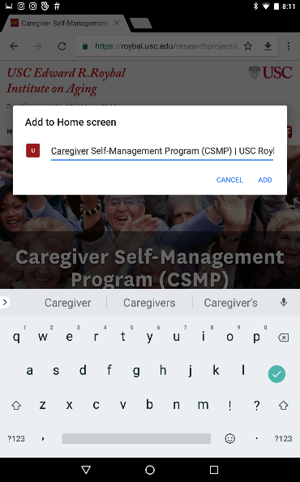 | 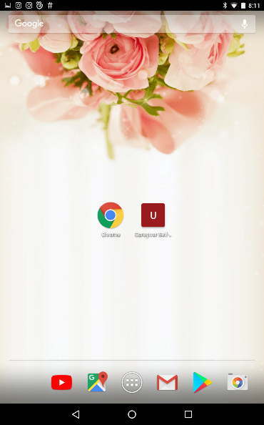
Tap the Chrome icon on the home screen (or whatever internet browser you use). | Enter the website | After entering the website, tap the three dots at the upper right hand corner | Tap Add to Home Screen | Type the name “USC course” or what you would like to name the icon, and tap Add | Return to your home screen, and you can find the shortcut

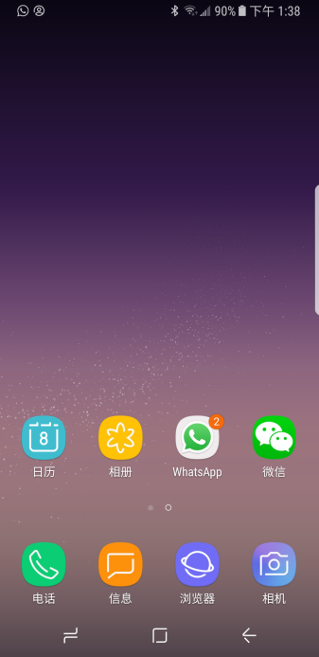 | 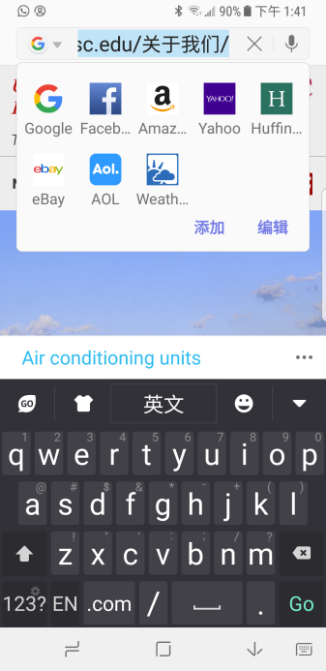 | 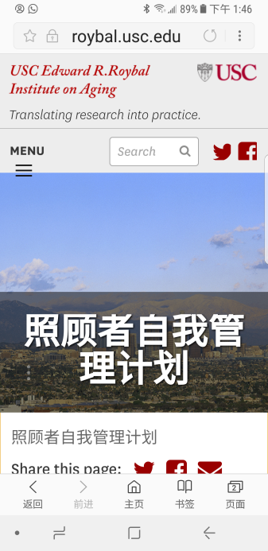 | 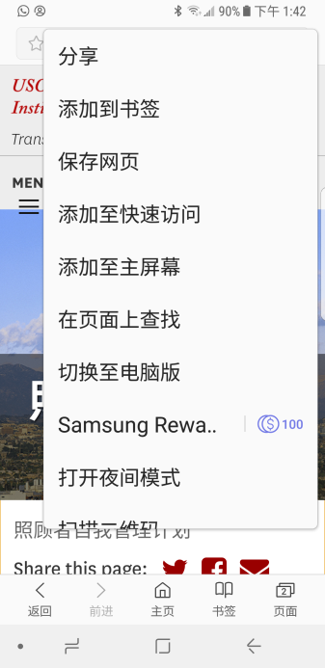 |  | 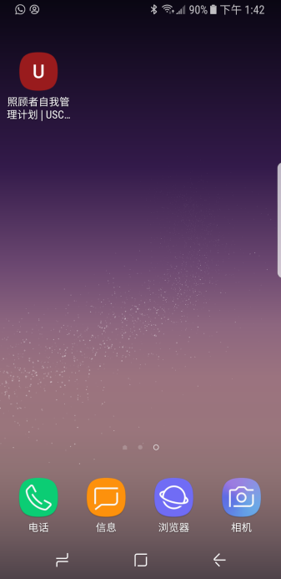
請在桌面上開啟您的瀏覽器 | 輸入網址 | 進入網站後請點選右上角圖示(三個點) | 點選添加至主屏幕 | 輸入南加大課程再點選新增(部分瀏覽器可略過此步驟) | 在主畫面中，即可找到網站捷徑

