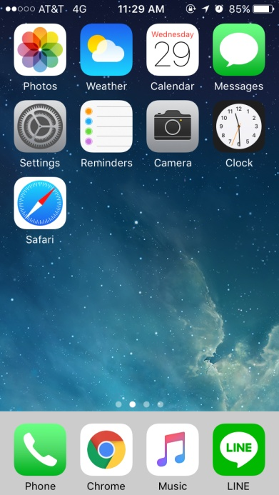 | 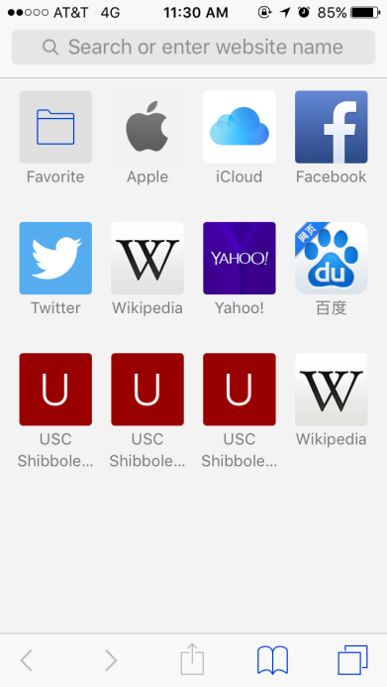 | 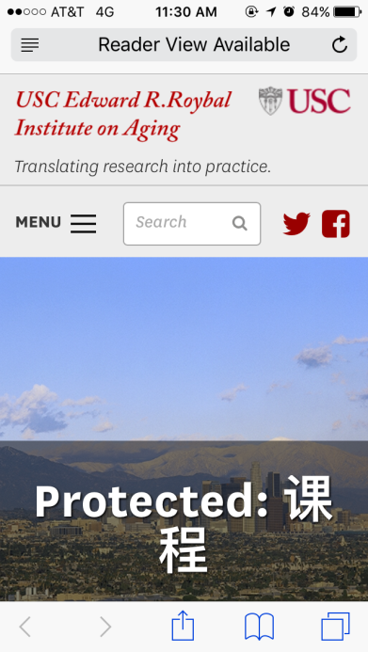 | 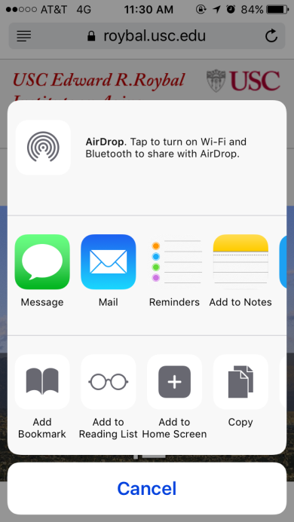 | 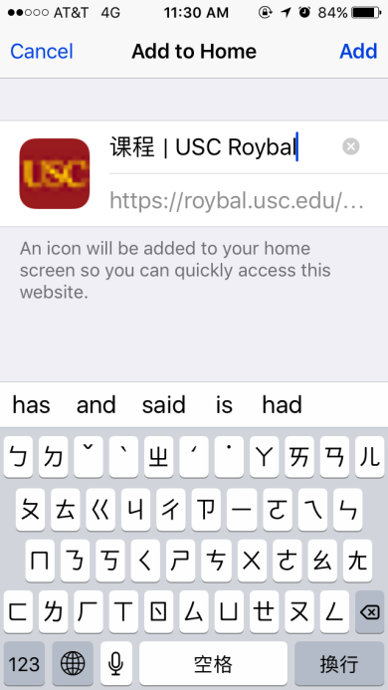 | 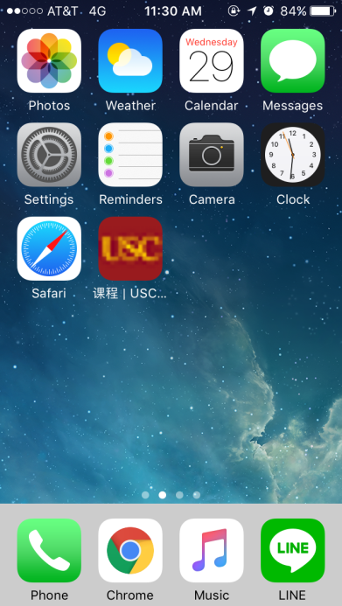
Please tap the Safari on the home screen. | Enter the website | After entering the website, please tap the icon in the bottom. | Please tap Add to home screen | Please type the “USC course” or tap Add directly | Press Home, you can find the shortcut on the home screen

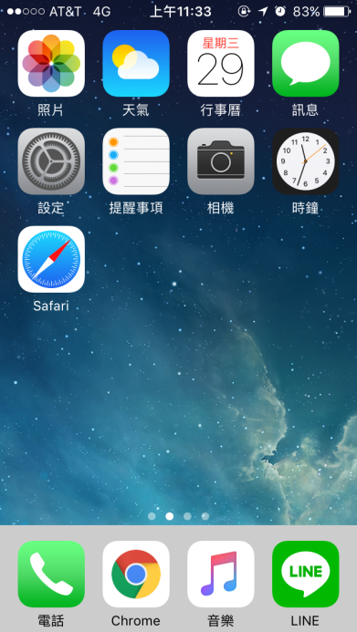 | 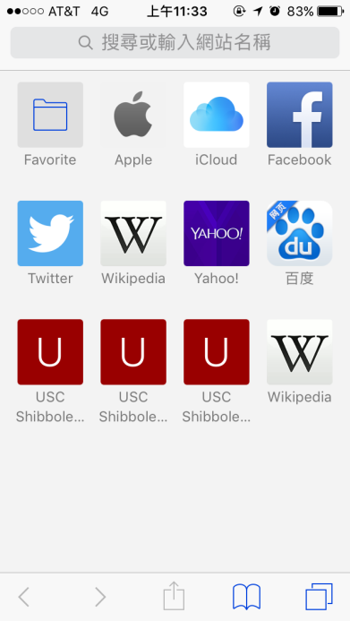 | 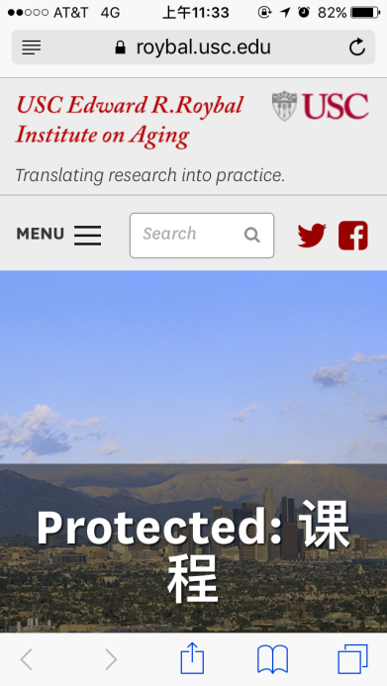 | 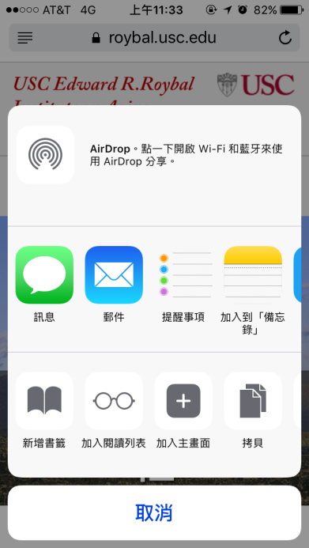 | 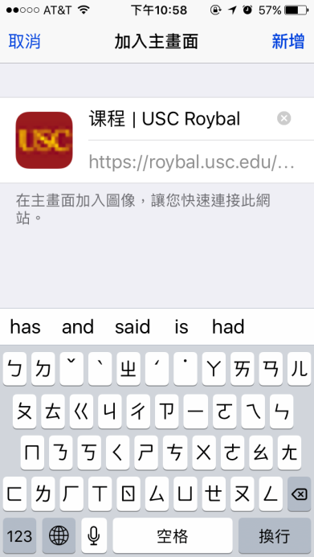 | 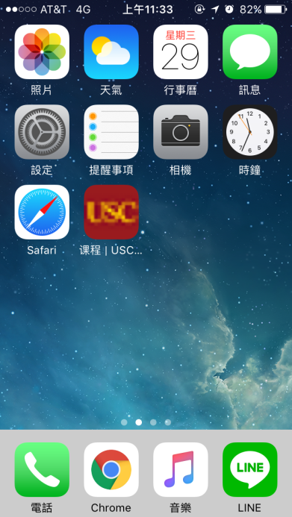
請在桌面上開啟Safari | 輸入網址 | 進入網站後點選下方圖示 | 從螢幕底端向上滑，點選加入主畫面 | 輸入南加大課程或是直接點選新增 | 在主畫面中，即可找到網站捷徑

